**Streamlining Email Classification in**

**Crime Investigation Department**

**Capstone Project Mentor Evaluation**

**Submitted by:**

**(102017059) Aakanksha Pandey**

**(102017060) Simranjit Kaur**

**(102017065) Rashmeet Kaur**

**(102017070) Garima Chandna**

**BE Third Year- CSE**

**CPG No. 162**

Under the Mentorship of Dr. Husanbir Singh Pannu (Assistant Professor)



**Computer Science and Engineering Department**

**Thapar Institute of Engineering and Technology, Patiala**

**May 2023**

Table of Contents

Functional Requirements 3

Non-Functional Requirements 4

Product Perspective 6

Use Case Diagram 7

Use Case Template and Scenarios 8

Activity Diagram 10

Class Diagram 11

Data Flow Diagrams 12

Component Design Diagram 14

3 Tier Architecture 15

Cost Analysis 15

# Functional Requirements

In order to achieve its primary objectives, the website should be designed for:

* Login Credentials: The system must require stakeholders to provide valid login credentials, including a username and password, to access the system.
* File Upload: The system must allow stakeholders to upload a file containing the complaint data in a supported format.
* Data Pre-processing: The system must pre-process the uploaded file by cleaning, normalizing, and standardizing the data to ensure accurate and consistent results
* Model Integration: The system must integrate with a trained machine learning model capable of classifying the complaint data into different buckets or categories.
* Category Segregation: The system must classify the uploaded complaint data into different categories based on the trained model's output.
* Display Results: The system must display the segregated data to stakeholders in an easy-to-understand and user-friendly manner.
* Export Functionality: The system must provide export functionality that allows stakeholders to export the segregated data in a supported format, such as CSV or Excel.

.

# Non-Functional Requirements

The system is expected to meet the following Non-Functional requirements for a smooth and seamless experience with the system.

Performance Requirements

The performance of our system is measured through how accurately the complaints have been classified into the various categories. It can also be justified by looking at how well the complaints have been matched. If the complaint is published with important keywords in it then only the performance requirements will be met.

* Modified data in the database should be updated for all users accessing it within two Seconds.
* The software should be portable, moving from one OS to other OS does not create any problem.
* The website should be able to run across various platforms and screen sizes like mobile phones, tablets and full-size computers.
* The program must be able to be run concurrently by multiple officials 24/7
* Evaluated complaint should be classified within 30 seconds
* Data should be updated in the database within 2 Seconds.

Safety Requirements

* Administrator should conduct a maintenance survey of the system after every six months.
* CID officials should not depend fully on this software.

Security Requirements

* The system must ensure the security and confidentiality of the uploaded data and any other sensitive information throughout the data processing and segregation process.
* The interface must be safe in terms of user data and confidentiality.
* Website should be secure according to the industry best practices.
* The Admin should keep the passwords secret and not share them with anyone.

Software Quality Attributes

* Simple Interface: Requirements for a UI ask that it be modern, easy to use and distinctive.
* Scalability: The system must be scalable to accommodate a large volume of complaint data and users over time.
* Reliability: Overall reliability of the system shall be achieved through the process of complaint segregation.
* Availability: The system shall be available to all the CID officials.
* Maintainability: The system should be updated from time to time.
* Error Handling: The system must have proper error handling mechanisms to ensure that stakeholders are notified in case of any errors or issues during the upload, processing, or segregation of the complaint data.

# Product Perspective

Our goal is to develop a software solution that streamlines the process of categorizing complaints based on their associated crimes. The software will be a user-friendly web application that utilizes an expert system consisting of multiple machine learning models. The primary objective of the project is to provide a decisive outcome that shows complaints categorized into one of six categories, including missing person, molestation, murder, theft, rape, and others. By employing this software solution, we aim to improve the efficiency and accuracy of complaint categorization, allowing officials to prioritize and address complaints more effectively.

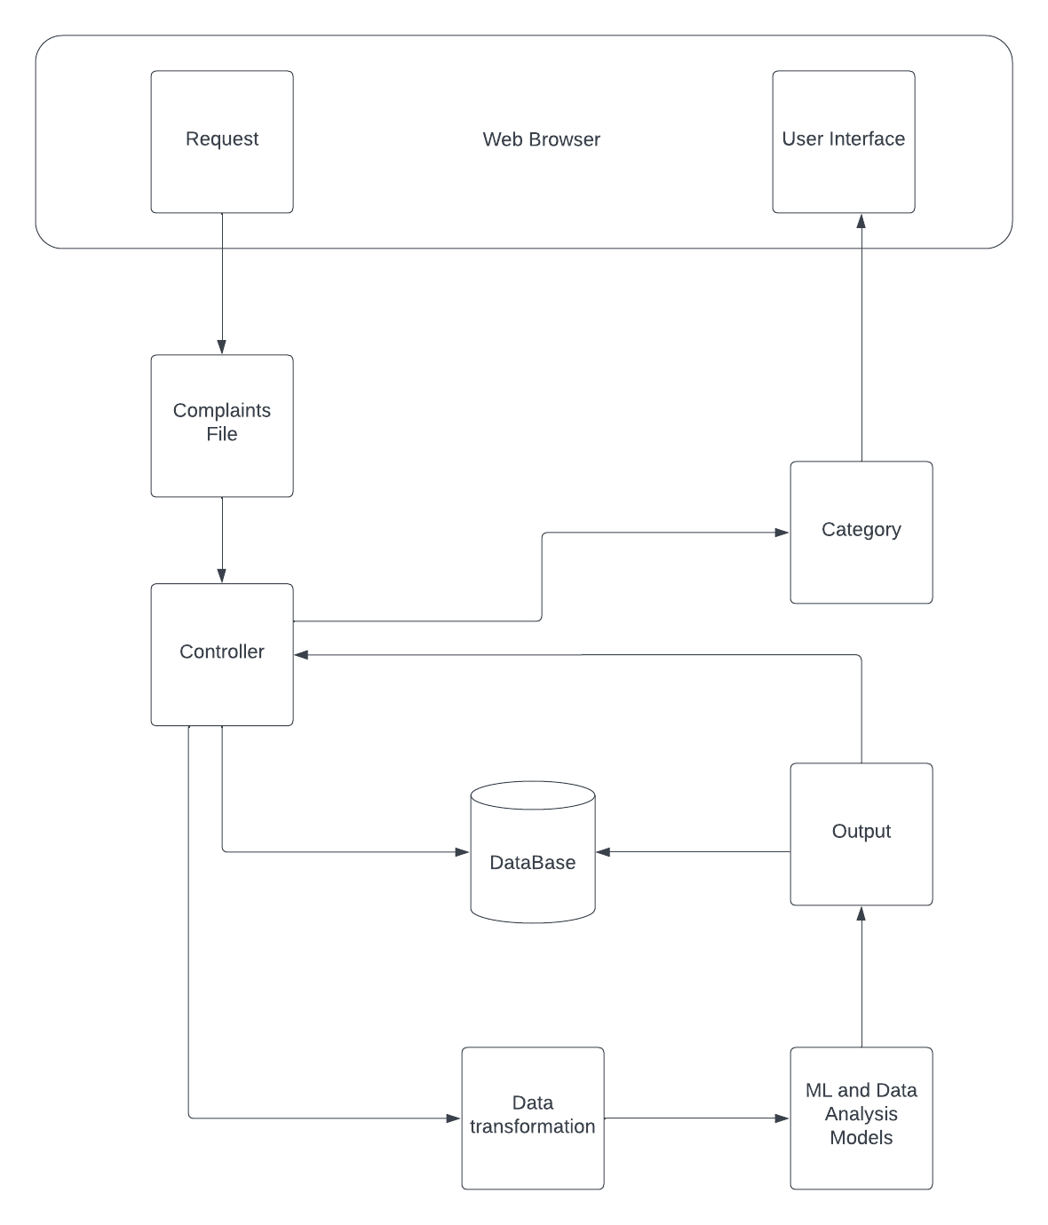

# Use Case Diagram

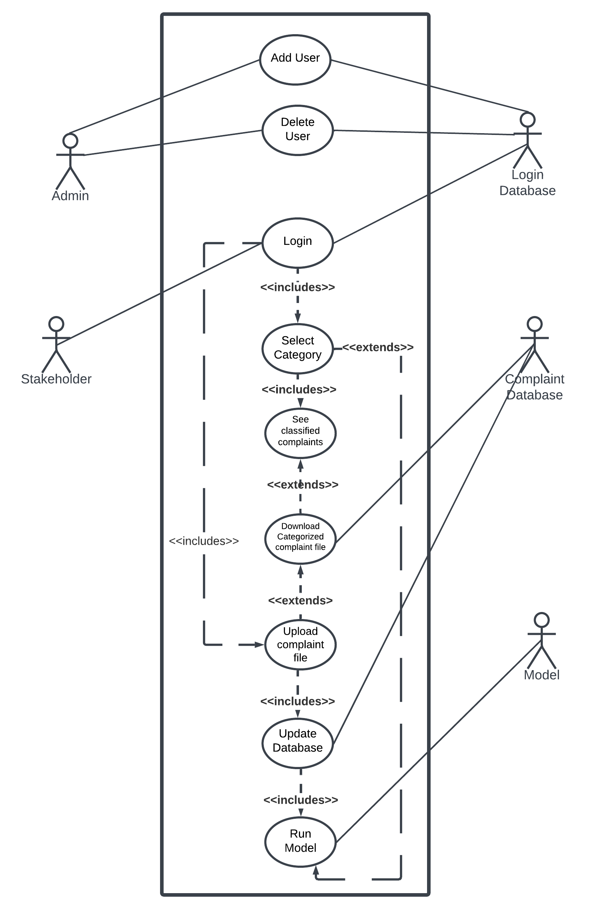

# Use Case Template and Scenarios

|  |  |  |  |  |
| --- | --- | --- | --- | --- |
| **Name of Use Case:** | Login | | | |
| **Created By:** | Simranjit Kaur | | **Last Updated By:** | Simranjit Kaur |
| **Date Created:** | 1/05/2023 | | **Last Revision Date:** | 5/05/2023 |
| **Description:** | | The homepage displays the login button for users. | | |
| **Actors:** | | Admin | | |
| **Preconditions:** | | 1. User must be registered. | | |
| **Postconditions:** | | 1. The database records are effectively maintained. | | |
| **Flow:** | | 1. User should enter the correct credentials. 2. Credentials from the database are matched with the entered credentials. 3. If the credentials match user is logged in successfully and then he/she can perform the desired actions | | |
| **Alternative Flows** | | 1. The User is not registered and cannot login. 2. The system displays an error message. | | |

|  |  |  |  |  |
| --- | --- | --- | --- | --- |
| **Name of Use Case:** | Classify complaints | | | |
| **Created By:** | Simranjit Kaur | | **Last Updated By:** | Simranjit Kaur |
| **Date Created:** | 1/05/2023 | | **Last Revision Date:** | 5/05/2023 |
| **Description:** | | The stakeholder uploads a file containing the complaint data, which is processed and segregated into different categories based on the trained machine learning model's output. | | |
| **Actors:** | | Stakeholder, Model, Database | | |
| **Preconditions:** | | 1. The stakeholder has a valid user account and login credentials. 2. The stakeholder has access to a file containing the complaint data in a supported format. 3. The system is running and is integrated with a trained machine learning model capable of classifying the complaint data into different categories. | | |
| **Postconditions:** | | 1. The uploaded file is processed, and the complaint data is successfully segregated into different categories based on the machine learning model's output. 2. The segregated data is displayed to the stakeholder in a user-friendly manner. | | |
| **Flow:** | | 1. The stakeholder logs in to the system using valid user account credentials. 2. The stakeholder selects the option to upload a file containing the complaint data. 3. The system prompts the stakeholder to select the file from their device. 4. The stakeholder selects the file and uploads it to the system. 5. The system processes the uploaded file by cleaning, normalizing, and standardizing the data to ensure accurate and consistent results. 6. The system integrates with the trained machine learning model to classify the complaint data into different buckets or categories. 7. The system segregates the complaint data into different buckets based on the machine learning model's output. 8. The system displays the segregated data to the stakeholder in an easy-to-understand and user-friendly manner. 9. The stakeholder logs out of the system. | | |
| **Alternative Flows** | | 1. If the stakeholder does not have valid user account credentials, the system prompts them to contact an administrator to request access. 2. If the uploaded file is not in a supported format, the system prompts the stakeholder to upload a valid file. 3. If the system fails to integrate with the machine learning model or encounter any other errors during the processing or segregation of the complaint data, the system notifies the stakeholder and prompts them to try again or contact an administrator for assistance. | | |

|  |  |  |  |  |
| --- | --- | --- | --- | --- |
| **Name of Use Case:** | Download Segregated Complaint Data | | | |
| **Created By:** | Garima Chandna | | **Last Updated By:** | Garima Chandna |
| **Date Created:** | 6/05/2023 | | **Last Revision Date:** | 6/05/2023 |
| **Description:** | | The stakeholder downloads a file containing the segregated complaint data in a supported format from the system. | | |
| **Actors:** | | Stakeholder, Database | | |
| **Preconditions:** | | 1. The stakeholder has a valid user account and login credentials. 2. The stakeholder has uploaded a file containing the complaint data and the system has successfully segregated the data into different categories based on the trained machine learning model's output. | | |
| **Postconditions:** | | 1. The segregated complaint data is successfully downloaded by the stakeholder in a supported format. | | |
| **Flow:** | | 1. The stakeholder logs in to the system using valid user account credentials. 2. The stakeholder selects the option to download the segregated complaint data. 3. The system generates the file containing the segregated complaint data in the supported format. 4. The system prompts the stakeholder to download the file. 5. The stakeholder downloads the file to their device. 6. The stakeholder logs out of the system. | | |
| **Alternative Flows** | | 1. If the stakeholder does not have valid user account credentials, the system prompts them to contact an administrator to request access. | | |

# Activity Diagram

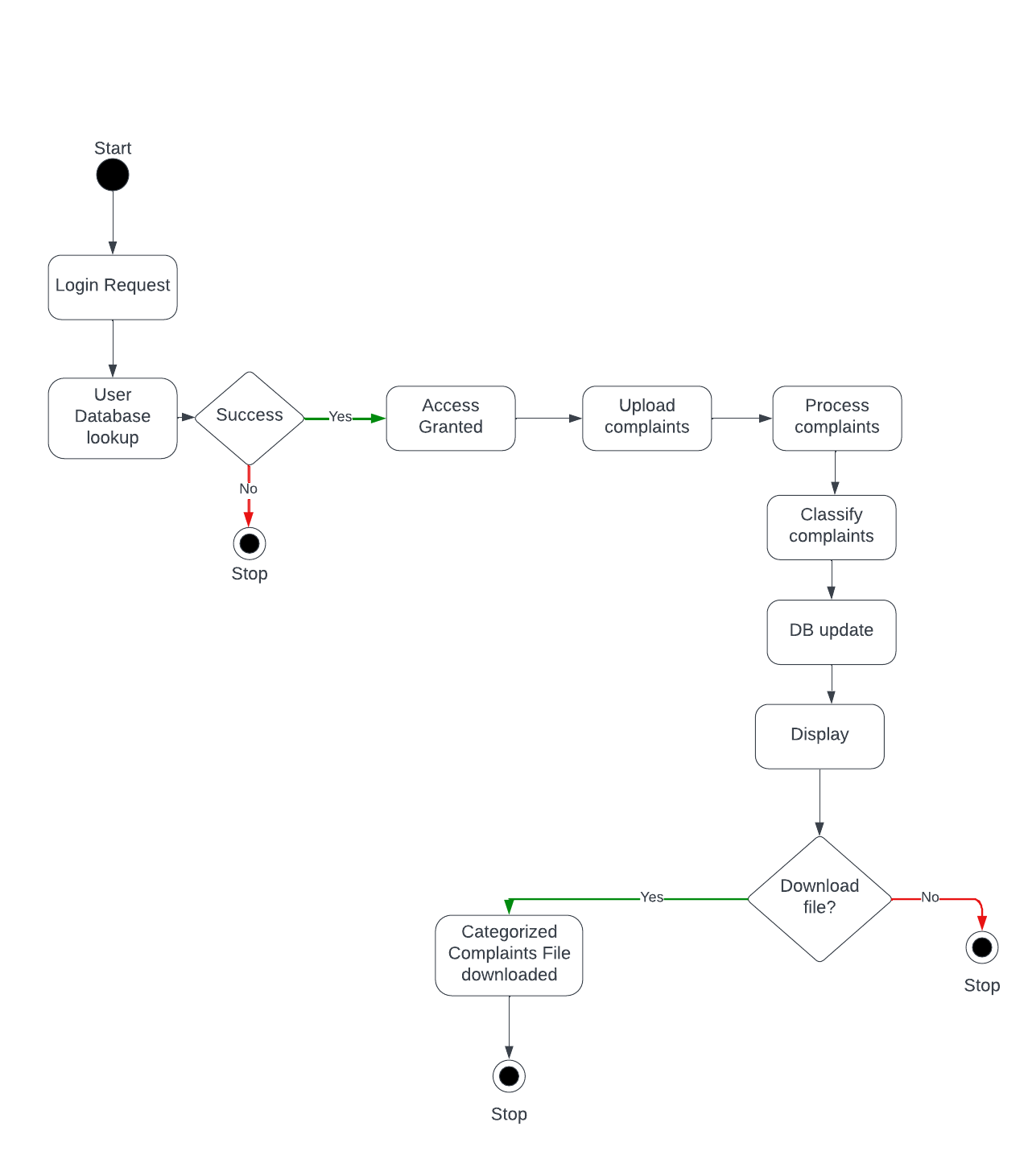

# Class Diagram

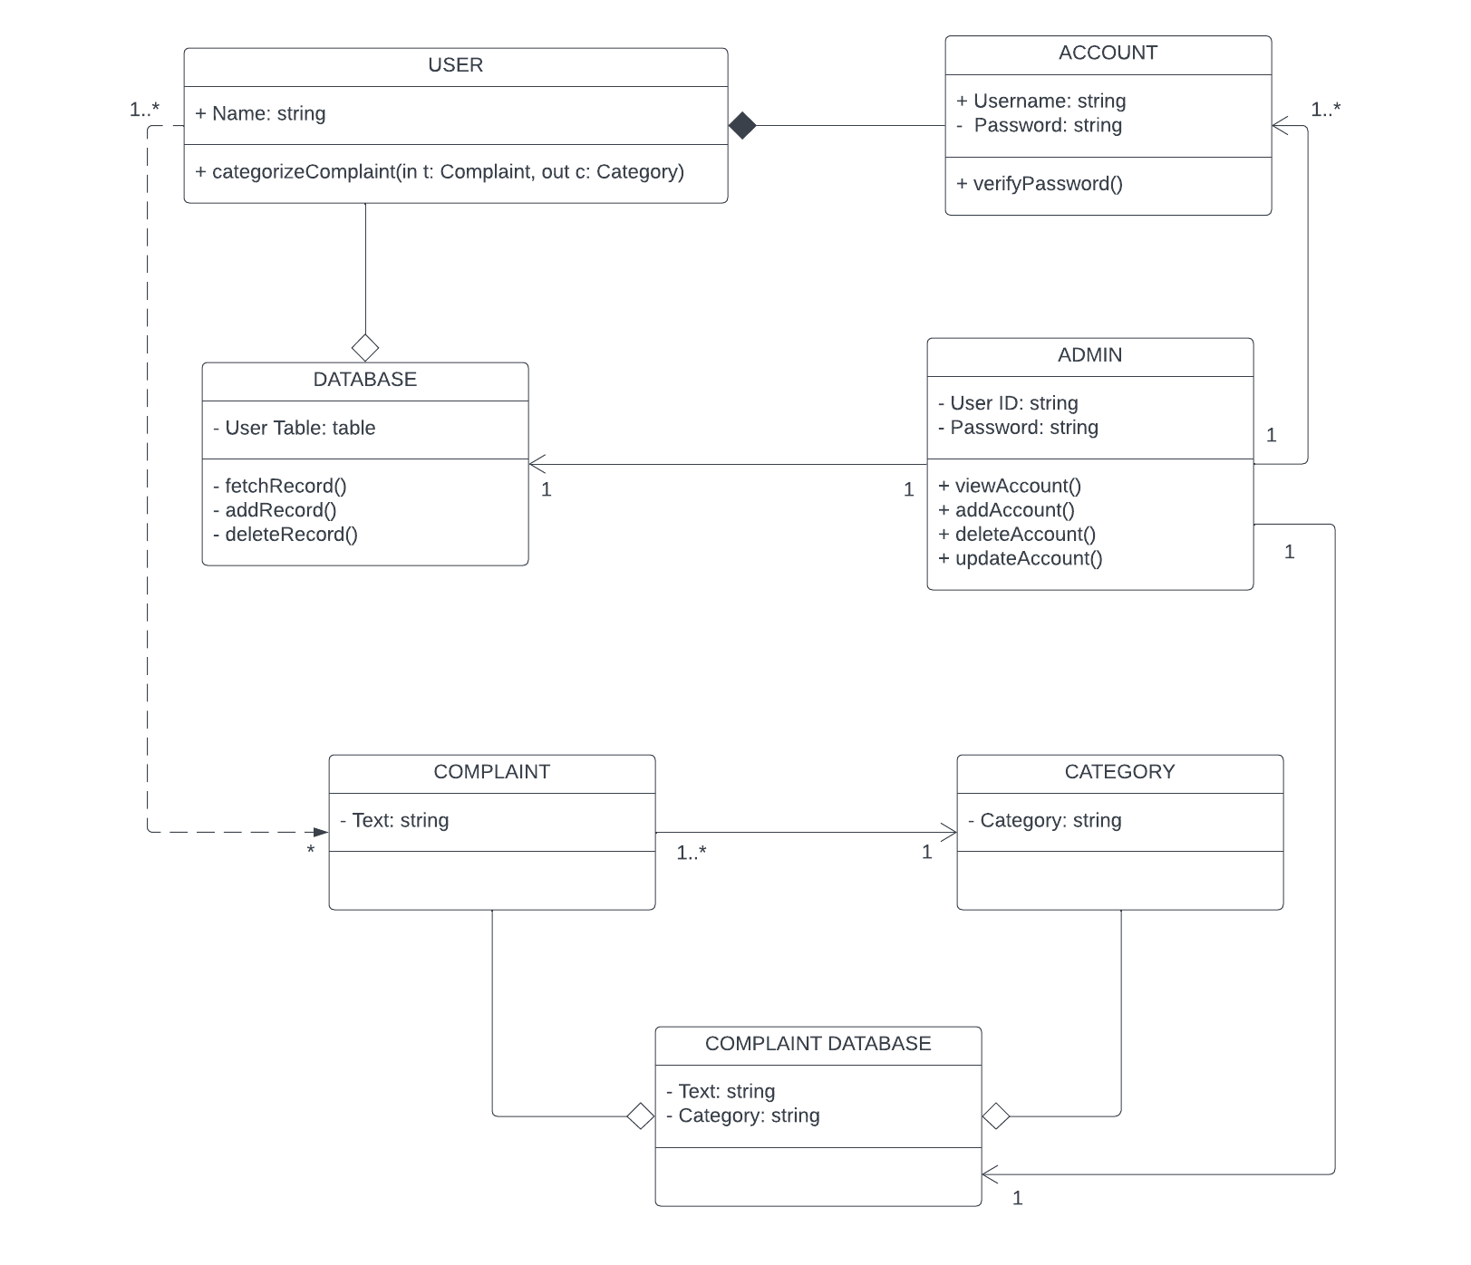

# Data Flow Diagrams

LEVEL 0 :

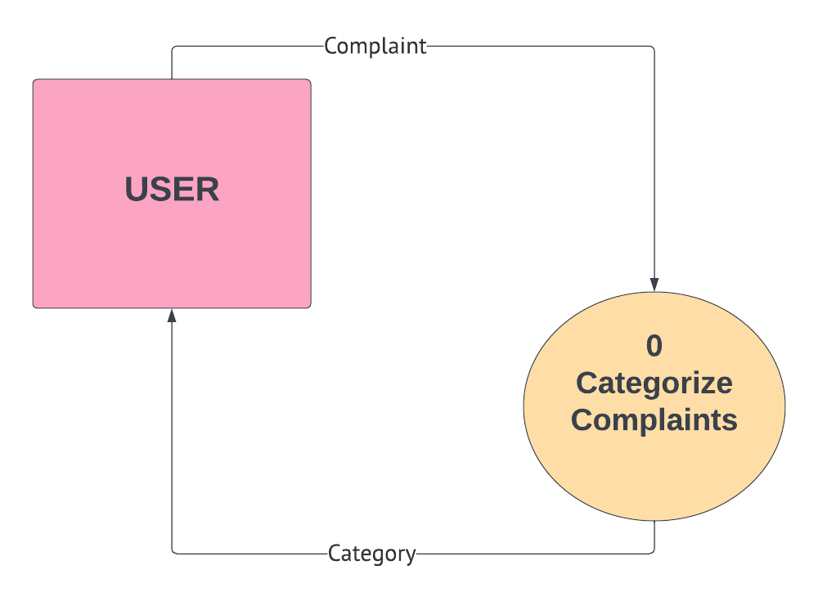

LEVEL 01 :

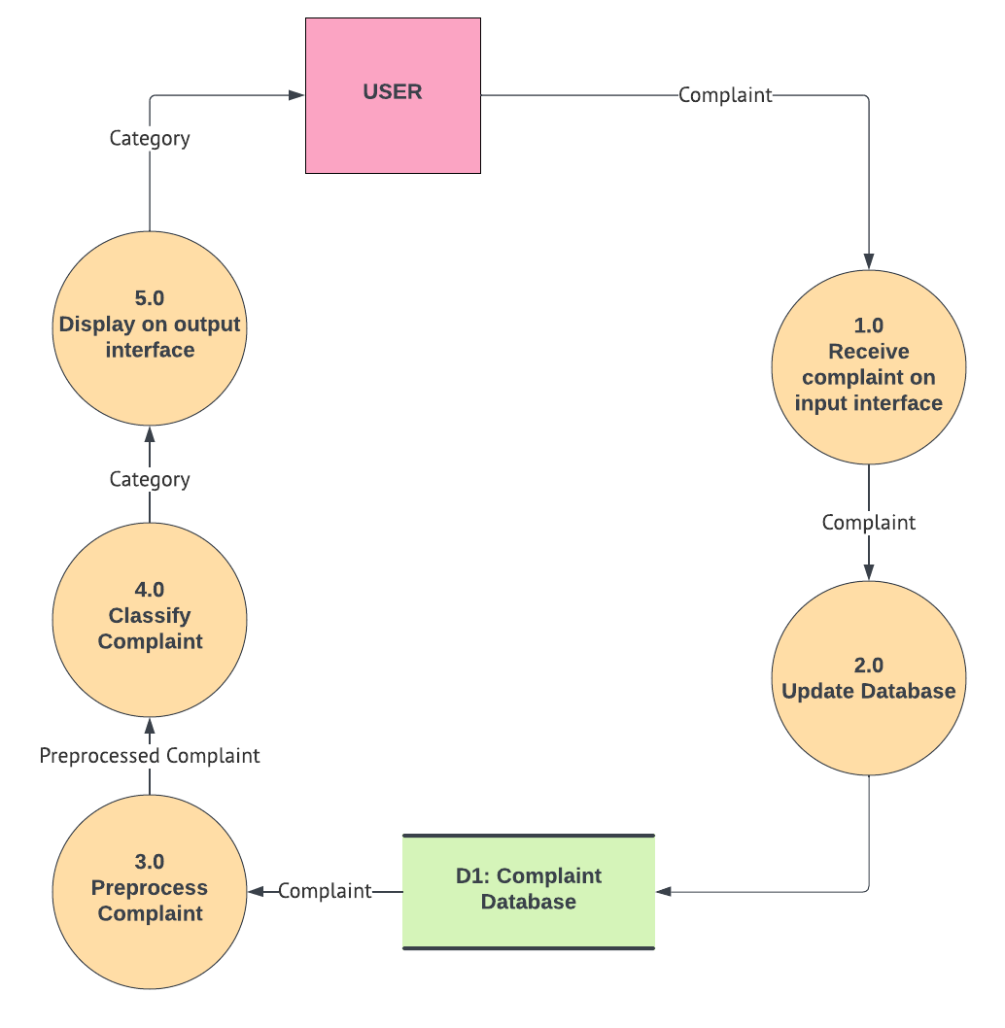

LEVEL 02:

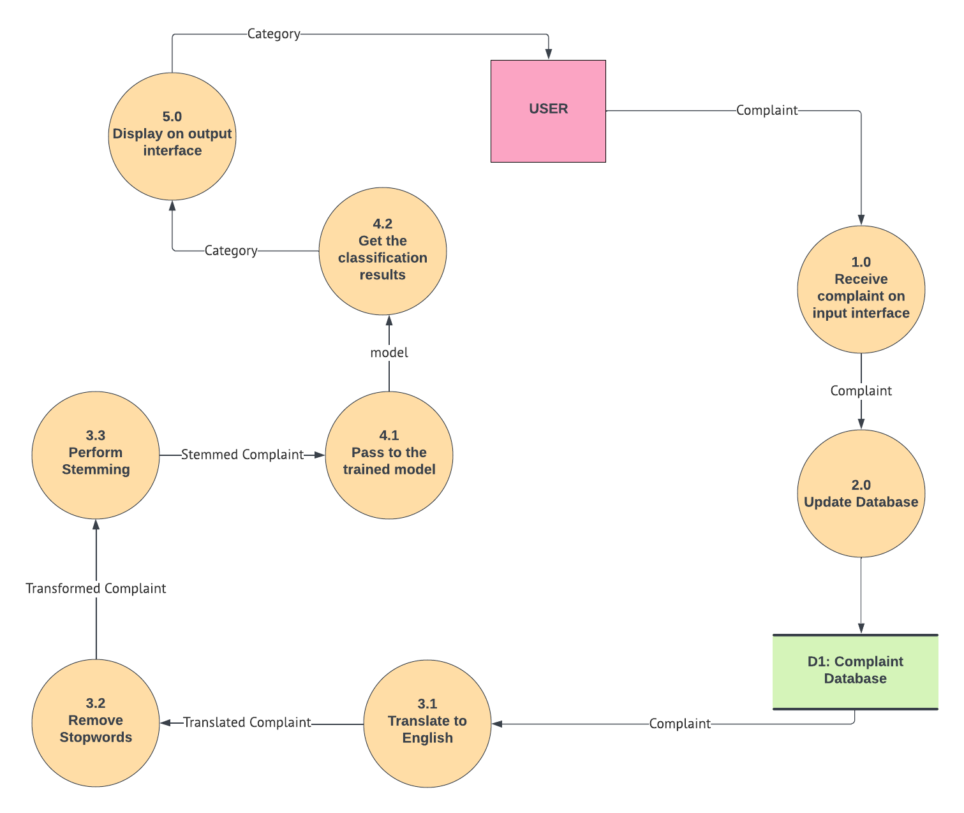

# Component Design Diagram

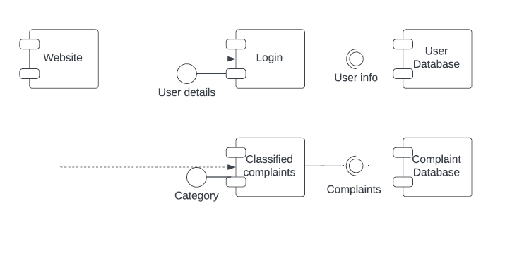

# 3 Tier Architecture

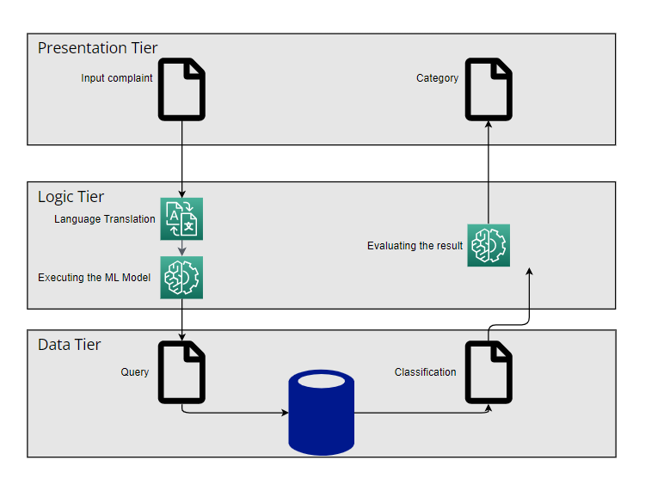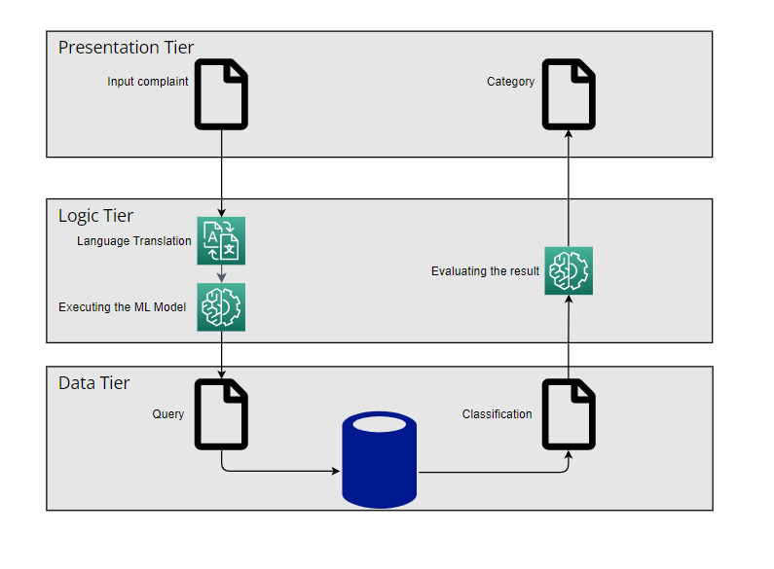     

# Cost Analysis

As of now there is no cost requirement as we are not using any hardware component. We only require an online platform to deploy our web-application